Experiment 27: Cropping, Copying and Pasting an Image inside Another Image using OpenCV
Software / Tools: Python · OpenCV (cv2) · NumPy

AIM
To crop a region from one image and paste (copy) it onto another image at a specified location using array slicing.
ALGORITHM
1. Import OpenCV and NumPy.
2. Read the source image.
3. Crop the desired region using array slicing: crop = img[y1:y2, x1:x2].
4. Create or read the destination/base image.
5. Paste the cropped region into the destination image using slice assignment: base[y:y+h, x:x+w] = crop.
6. Display and save the resulting composite image.
PROGRAM (SOURCE CODE)
import cv2
import numpy as np

img = cv2.imread("image.jpg")
base = cv2.imread("background.jpg") # destination image

# Crop a region from the source image
crop = img[150:320, 300:470]

# Paste the cropped region onto the base image at (40, 40)
pasted = base.copy()
pasted[40:40 + crop.shape[0], 40:40 + crop.shape[1]] = crop

cv2.imwrite("crop_paste_output.jpg", pasted)
cv2.imshow("Cropped and Pasted", pasted)
cv2.waitKey(0)
cv2.destroyAllWindows()

OUTPUT
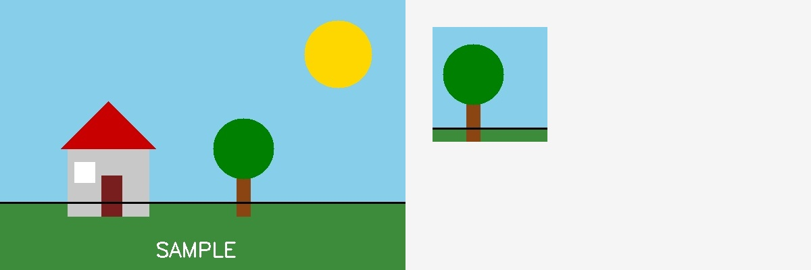
Fig. 27 — Output of Experiment 27: Cropping, Copying and Pasting an Image inside Another Image using OpenCV.
RESULT
Crop a region from one image and paste (copy) it onto another image at a specified location using array slicing — completed successfully, as demonstrated in the output shown above.

